**CSE 572: ACTIVITY RECOGNITION WITH MACHINE LEARNING PROJECT**

**Team 21:**

Sucharitha Rumesh - 1213120166 - <srumesh@asu.edu>

Shiva Chandrashekhar - 1215106256 - <snchand1@asu.edu>

Ryan Ang - 1206143792 - <rang1@asu.edu>

Akhila Muthyala - 1213175494 - <amuthyal@asu.edu>

Nikhilesh Sadasivam - 1215175247 - <nsadassi@asu.edu>

# Assignment 2

For assignment 2, we picked user 10 and the utensil “spoon” to test machine learning. From the data in the GroundTruth folder, we selected the first 20 rows. Each row was considered one eating action. Each row was multiplied by 50 and divided by 30 to get the row number in the data from MyoData. The Myodata contained sensor data and we used “accelerometer”.

After getting 20 eating data, we then selected the first 20 non-eating data from GroundTruth.

To build the input for machine learning techniques, Decision Tree, Neural Network, and Support Vector Machine, we took 60% of the data as training and 40% as testing. Since there were 20 eating actions and 20 non-eating actions, a total of 24 actions was used for testing and a total of 16 actions was for training. The following sections are five feature extractions, “Discrete Wavelet”, “Average”, “Fast Fourier Transform”, “Root mean square” and “Standard Deviation”. We Then used a Decision tree, Neural Network, and a Support Vector Machine and passed the five feature extracted data to these three machines. Some features had high values for precision, recall, and F1 for certain machines and low for the rest. It can be seen that out of the three machines used, every feature had almost consistent values when using a Support Vector Machine.

For every machine learning method used, the precision, Recall, and F1 are calculated using:

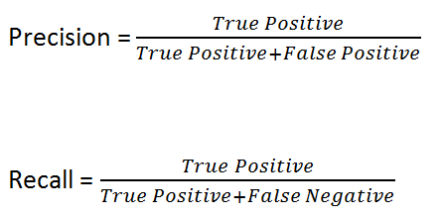

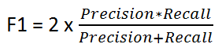

## 1. User 10 data

### Discrete wavelet transform

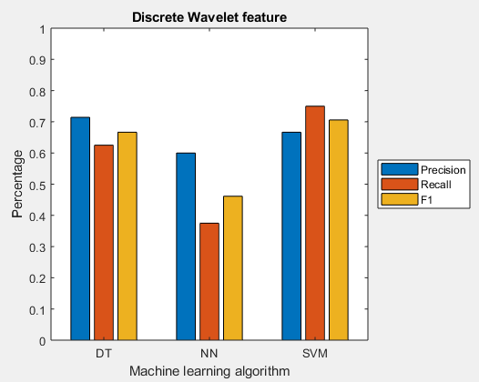

Using SVM, training 24 actions for on feature "Discrete Wavelet" produces

Precision 0.67

Recall 0.75

F1-Score 0.71

Using DT, training 24 actions for on feature "Discrete Wavelet" produces

Precision 0.71

Recall 0.63

F1-Score 0.67

Using NN, training 24 actions for on feature "Discrete Wavelet" produces

Precision 0.60

Recall 0.38

F1-Score 0.46

When using the Discrete wavelength features extracted on the three machines, we can infer that the Decision tree and the Support Vector machine gave more uniform results when compared to Neural Networks. But we tend to prefer SVM for DWT because of a better performance in Recall and F1.

### Average

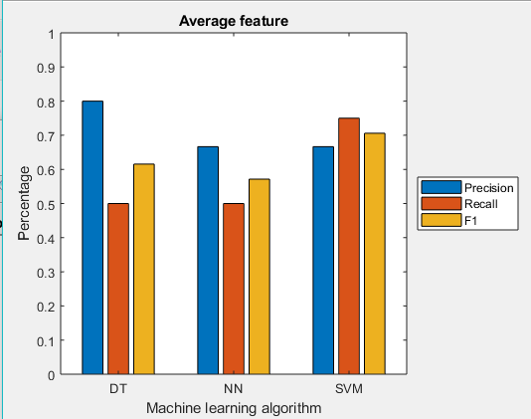

Using SVM, training 24 actions for on feature "Average" produces

Precision 0.67

Recall 0.75

F1-Score 0.71

Using DT, training 24 actions for on feature "Average" produces

Precision 0.80

Recall 0.50

F1-Score 0.62

Using NN, training 24 actions for on feature "Average" produces

Precision 0.67

Recall 0.50

F1-Score 0.57

When using the average feature on the three machine learning algorithms, we could say that this feature provided similar looking results on the three machines but again clearly, SVM produces similar and relatively high-performance metrics and hence we prefer that.

### Fast Fourier Transform

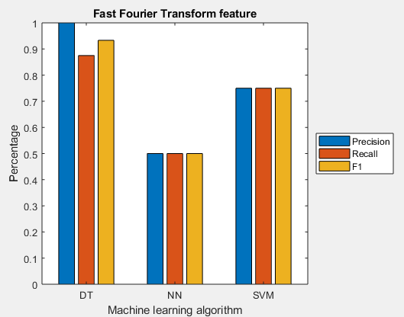

Using SVM, training 24 actions for on feature "Fast Fourier Transform" produces

Precision 0.75

Recall 0.75

F1-Score 0.75

Using DT, training 24 actions for on feature "Fast Fourier Transform" produces

Precision 1.00

Recall 0.88

F1-Score 0.93

Using NN, training 24 actions for on feature "Fast Fourier Transform" produces

Precision 0.50

Recall 0.50

F1-Score 0.50

The Fast Fourier Transform feature, when used on the three machines, provided some variable results based on the machine. This feature, when executed on a Neural Network, yielded performance metrics that were below par which were also coincidentally equal to each other. Decision trees provided us with perfect precision and highest relative recall and F1-score values, hence we prefer that.

### Root mean square

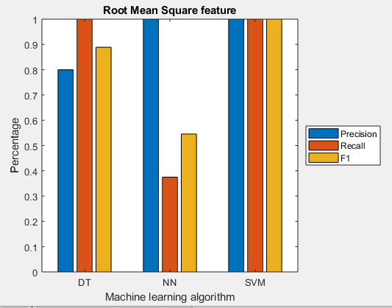

Using SVM, training 24 actions for on feature "Root Mean Square" produces

Precision 1.00

Recall 1.00

F1-Score 1.00

Using DT, training 24 actions for on feature "Root Mean Square" produces

Precision 0.80

Recall 1.00

F1-Score 0.89

Using NN, training 24 actions for on feature "Root Mean Square" produces

Precision 1.00

Recall 0.38

F1-Score 0.55

The Root Mean Square feature has a high precision on all the three machines applied but the Support Vector Machine provides us with the highest values possible for Precision and Recall too.

### Standard deviation

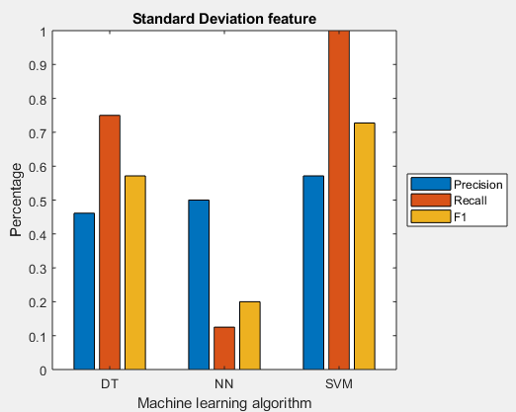

Using SVM, training 24 actions for on feature "Standard Deviation" produces

Precision 0.57

Recall 1.00

F1-Score 0.73

Using DT, training 24 actions for on feature "Standard Deviation" produces

Precision 0.46

Recall 0.75

F1-Score 0.57

Using NN, training 24 actions for on feature "Standard Deviation" produces

Precision 0.50

Recall 0.13

F1-Score 0.20

The Standard Deviation feature showed the most varying performance metrics for the different types of machine learning algorithms used. The Neural Network shows the least performance among the three. The decision tree shows better performance than Neural Networks but lacks in precision. The Support Vector Machine, however, shows the most promising results for using this feature.

## 2. Raw data for other users

To produce results for the other users, we have taken user10’s machine learning model and performed the testing datasets of each user on it. The following tables are for the 5 feature extractions

### Discrete wavelet transform

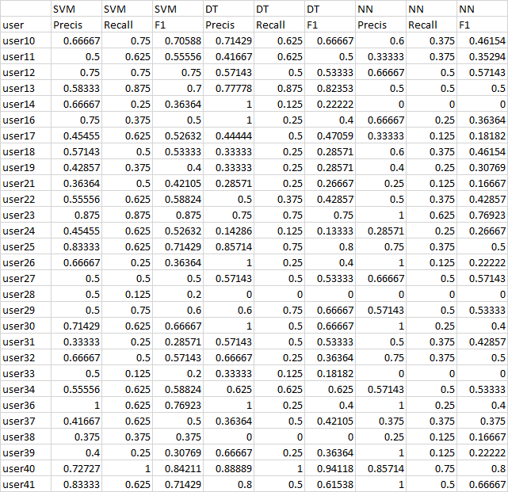

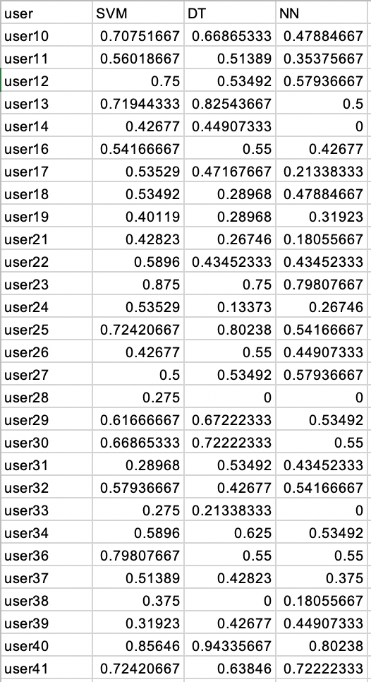

After taking the average value of Precision, Recall and F1 score from the raw table for SVM, DT & NN, this what we infer.

SVM:

User28, User33 has the lowest SVM score for DWT.

User23 has the highest SVM score for DWT.

DT:

User28, User38 has the lowest DT score for DWT.

User40 has the highest DT score for DWT.

NN:

User14, USer28, User33 has the lowest NN score for DWT.

User40 has the highest NN score for DWT.

### Average

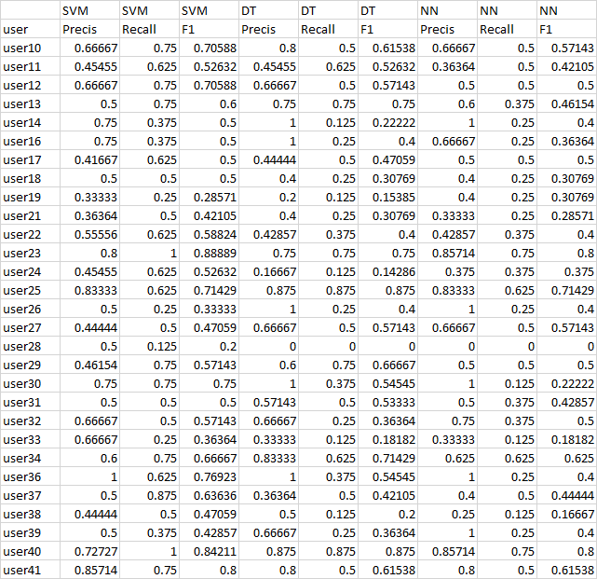

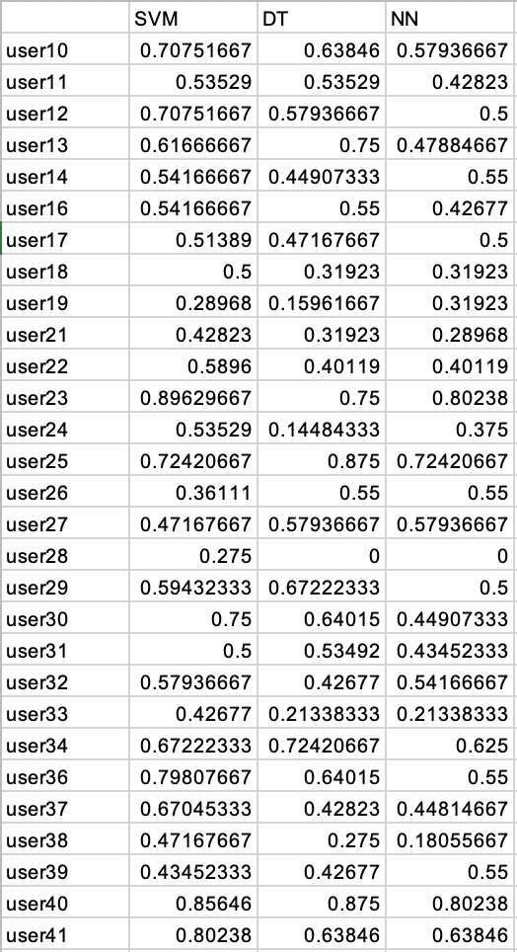

After taking the average value of Precision, Recall and F1 score from the raw table for SVM, DT & NN, this what we infer.

SVM:

User28 has the lowest SVM score for Average

User23 has the highest SVM score for Average

DT:

User24 has the lowest DT score for Average.

User25 & User40 has the highest DT score for Average.

NN:

User38 has the lowest NN score for Average.

User23 & User40 has the highest NN score for Average.

### Fast Fourier Transform

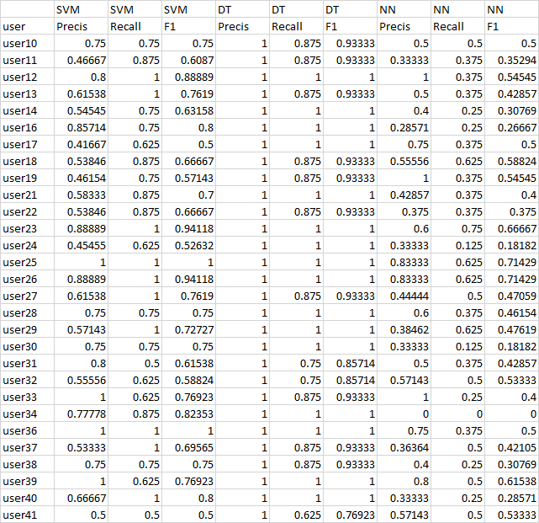

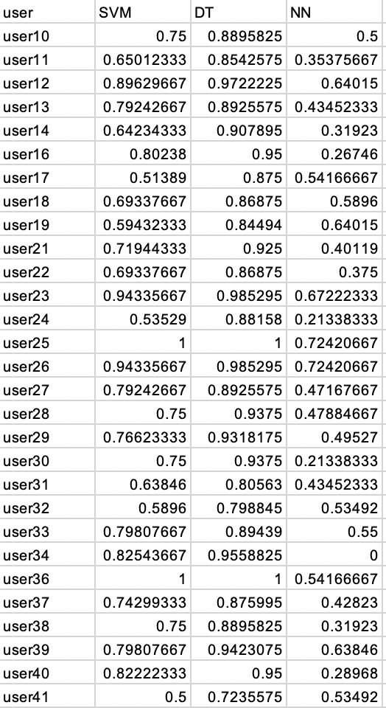

After taking the average value of Precision, Recall and F1 score from the raw table for SVM, DT & NN, this what we infer:

SVM:

User41 has the lowest SVM score for FFT.

User25 & User36 has the highest SVM score for FFT.

DT:

User41 has the lowest DT score for FFT.

User25 & User36 has the highest DT score for FFT.

NN:

User34 has the lowest NN score for FFT.

User25 & User26 has the highest NN score for FFT.

### Root mean square

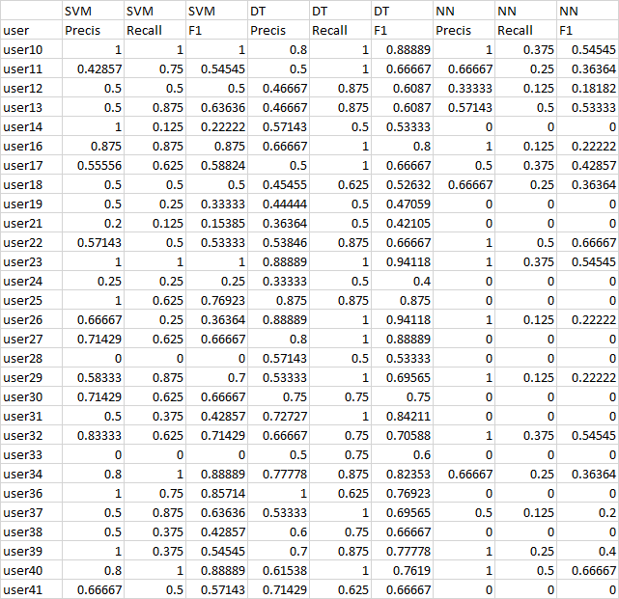

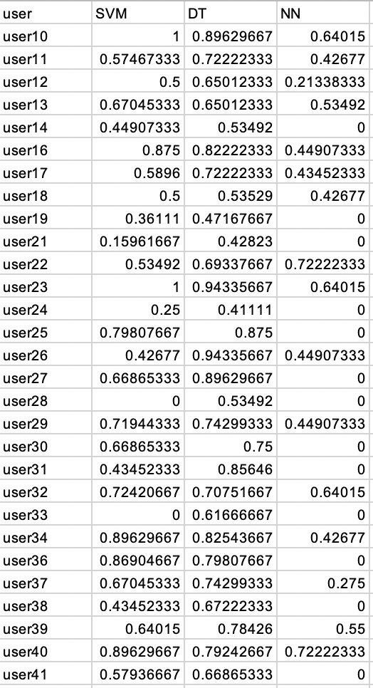

After taking the average value of Precision, Recall and F1 score from the raw table for SVM, DT & NN, this what we infer:

SVM:

User28 & User33 has the lowest SVM score for RMS.

User10 & User 23 has the highest SVM score for RMS.

DT:

User24 has the lowest DT score for RMS.

User23 & User26 has the highest DT score for RMS.

NN:

User14, User19, User21, User24, User25, User27, User28, User30, User31, User33, User36, User38 & User41 has the lowest NN score for RMS

User22 & User40 has the highest NN score for RMS.

### Standard deviation

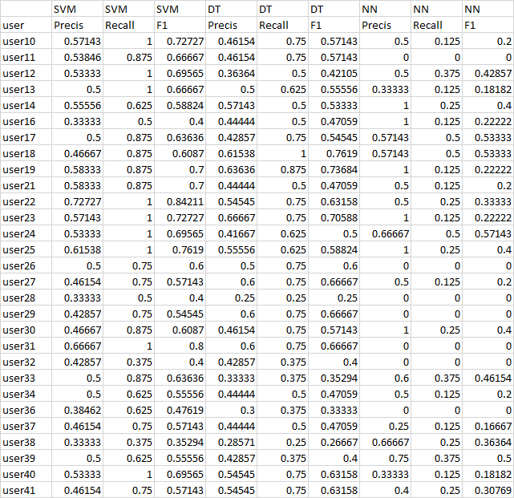

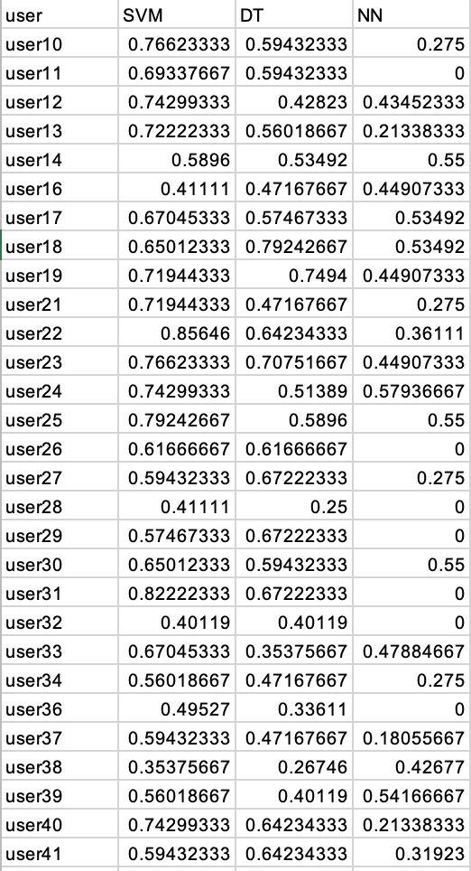

After taking the average value of Precision, Recall and F1 score from the raw table for SVM, DT & NN, this what we infer:

SVM:

User38 has the lowest SVM score for STD.

User22 has the highest SVM score for STD.

DT:

User28 has the lowest DT score for STD.

User18 has the highest DT score for STD

NN:

User11, User26, User28, User29, User31, User32, User36 has the lowest NN score for STD.

User24 has the highest NN score for STD.

# Assignment 3

For assignment 3, we picked users 10 through 31 and the utensil “spoon” to test machine learning. From the data in GroundTruth folder, we selected the first row for each user. One row was considered one eating action. The row was multiplied by 50 and divided by 30 to get the row number in the data from MyoData. The Myodata contained sensor data and we used “accelerometer”.

After getting 20 users’ eating data, we then selected the first non eating data from GroundTruth from each user.

To build the input for machine learning techniques, Decision Tree, Neural Network, and Support Vector Machine, we took 60% of the data as training and 40% as testing. Since there were 20 eating actions and 20 non eating actions, a total of 24 actions was used as testing and a total of 8 actions was for training. The following sections are five feature extractions, “Discrete Wavelet”, “Average”, “Fast Fourier Transform”, “Root mean square” and “Standard Deviation”. Once the training and testing of the the user data was done in the Decision Tree, Neural Network and Support Vector machine, the trained machines are used to predict the classification of the eating action for 20 users. For the classification of the 20 users data, the Support vector machine has shown consistent results over all the 5 different types of feature extracted data when compared to the Decision tree or Neural network. The performance of these Machine learning algorithms are measured by calculating the three performance metric: Precision, Recall and F1.

### Discrete wavelet transform

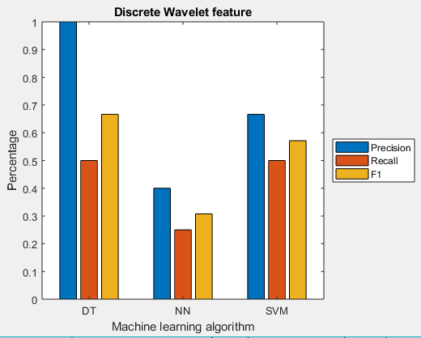

Using SVM, training 24 users for on feature "Discrete Wavelet" produces

Precision 0.67

Recall 0.50

F1-Score 0.57

Using DT, training 24 users for on feature "Discrete Wavelet" produces

Precision 1.00

Recall 0.50

F1-Score 0.67

Using NN, training 24 users for on feature "Discrete Wavelet" produces

Precision 0.40

Recall 0.25

F1-Score 0.31

While predicting using the Discrete wavelet feature, the Decision tree has shows a considerably higher performance based on Precision and F1 while recall is the same as that generated by SVM. NN shows below par results.

### Average

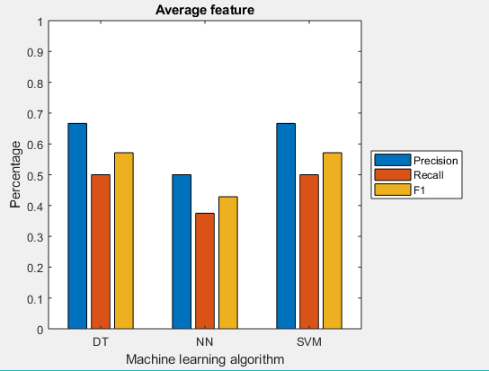

Using SVM, training 24 users for on feature "Average" produces

Precision 0.67

Recall 0.50

F1-Score 0.57

Using DT, training 24 users for on feature "Average" produces

Precision 0.67

Recall 0.50

F1-Score 0.57

Using NN, training 24 users for on feature "Average" produces

Precision 0.50

Recall 0.38

F1-Score 0.43

Using the average feature to classify the data, all the machines have a similar performance. The Support Vector machine performs exactly like Decision Trees yielding the same results. The difference in performance between NN and others is not significant but we still prefer SVM or DT.

### Fast Fourier Transform

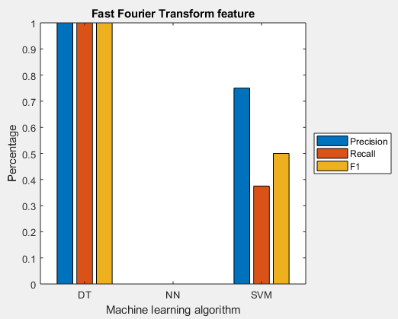

Using SVM, training 24 users for on feature "Fast Fourier Transform" produces

Precision 0.75

Recall 0.38

F1-Score 0.50

Using DT, training 24 users for on feature "Fast Fourier Transform" produces

Precision 1.00

Recall 1.00

F1-Score 1.00

Using NN, training 24 users for on feature "Fast Fourier Transform" produces

Precision 0.00

Recall 0.00

F1-Score 0.00

Using the Fast Fourier Transform features to predict, the Decision tree has an absolute performance compared to the other machines based on these performance metric.

### Root mean square

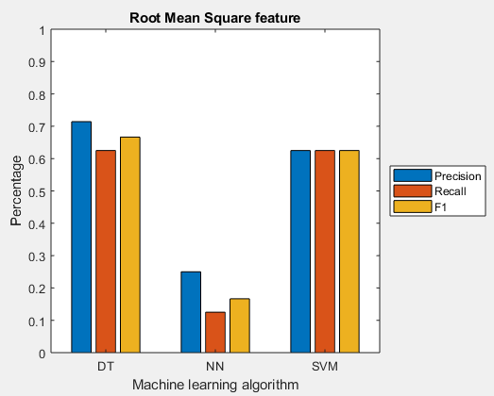

Using SVM, training 24 users for on feature "Root Mean Square" produces

Precision 0.63

Recall 0.63

F1-Score 0.63

Using DT, training 24 users for on feature "Root Mean Square" produces

Precision 0.71

Recall 0.63

F1-Score 0.67

Using NN, training 24 users for on feature "Root Mean Square" produces

Precision 0.25

Recall 0.13

F1-Score 0.17

The Decision tree algorithm has better performance for classifying using Root mean square as the feature, but the Support vector Machine has a consistent performance over the three performance metrics.

### Standard deviation

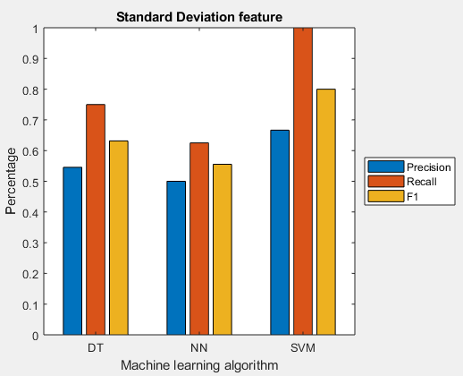

Using SVM, training 24 users for on feature "Standard Deviation" produces

Precision 0.67

Recall 1.00

F1-Score 0.80

Using DT, training 24 users for on feature "Standard Deviation" produces

Precision 0.55

Recall 0.75

F1-Score 0.63

Using NN, training 24 users for on feature "Standard Deviation" produces

Precision 0.50

Recall 0.63

F1-Score 0.56

The Support Vector Machine has a better overall performance over classifying the data. Using the Standard Deviation for feature selection, the Support Vector machine has a performance when compared to Neural Network and Decision Trees.